DIS-Axe-Monolithic- Brawner

The Southeastern Monolithic Axe

Tim Brawner, Dothan, Alabama

The apex of the Woodland Period sparked the development of the great chiefdoms of the Missis­sippian. During this period the Southeastern Ceremonial Complex emerged as a major Missis­sippian complex. This complex appeared chronologically late, Middle to Late Mississippian, and existed throughout the southeast, extending from the Gulf Coast to Oklahoma and as far north as the Great Lakes. Although the complex appears widespread, the primary cultural centers were Spiro, along the Arkansas River in Le Flore County, Oklahoma; Moundville, along the Black Warrior river in Hale County, Alabama; and Etowah, along the Etowah River in Bartow County, Georgia. The heart of the complex appears to be Spiro. Fifty-two percent of the ceremonial manifestations occur at all three of these ceremo­nial centers, and 83% of the materials occur at either Spiro and Moundville, or Spiro and Etowah.

Among the rarer ceremonial objects associated with this complex are the monolithic axes; less than 25 are reported from the central southern portion of the United States. Monolithic axes are a highly specialized representation of the hafted celt, carved from a single piece of stone, highly polished and exhibiting little to no use or wear. Most specimens have a raised or expanding coni­cal extension at the butt of the handle, containing an eyelet which runs parallel with the blade or celt. The top of the handle often tapers to an edge or hooks toward the poll end of the celt (Foreman and Fundaburk, 1957: pg 39-44, plate 90).

Examples of these unique artifacts are reported from the following areas and represent the known axes identified with the Southeastern Ceremonial Complex. Undoubtedly others exist; however, this compilation represents the majority of these known artifacts. It does not represent any chronol­ogy or geographic division.

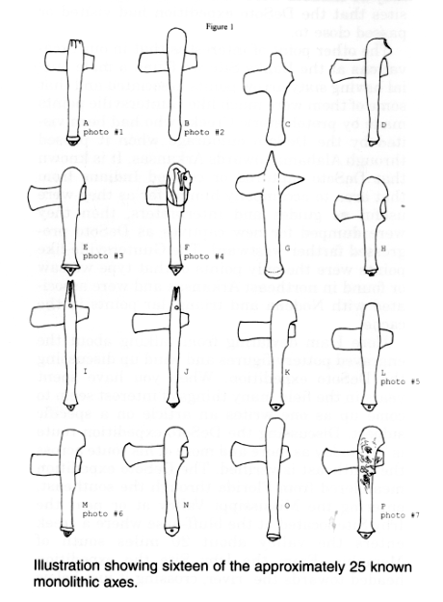

Axe #1 - Figure 1A, Photo #1

The earliest reported monolithic axe was recov­ered by Dr. Joseph Jones in 1868/1869 from the East Tennessee Mounds. This axe was recovered from a mound on the eastern bank of the Cumber­land River near Nashville, Tennessee. This exam­ple is 13 3/8 inches long; 5 3/4 inch celt length, and is made of a green chloritic material or greenstone. The mound was about 10 feet high, 100 feet in diameter, and contained a sacrificial altar surrounded by a circle of stone coffins. This axe was recovered from a male/female burial, under the skull of the male individual. The burial was located on the southern slope of the mound near the altar. The upper end of the handle tapers to a square, with three incised grooves carved on each side extending about half way down toward the celt. This axe is curated at the Museum of the American Indian; Heye Foundation, New York, New York; catalog number MAI/HF: 7775. (Saville, 1916: pg 4; Brehm and Smothermon, 1989: pg 15-19)

Axe #2 - Figure 1B, Photo #2

Another specimen was recovered in the late 1800's, from the Calvary mound in northeastern Mississippi County, Arkansas. This example is 14.41 inches long, made of a medium polished olive-green diorite with damage to the bit of the celt. Several sources state the length as 13 3/4, while others state the length as 11 3/4; however, museum records indicate the length as 14.41 inches (36.6 centimeters). This axe was donated to the Smithsonian in 1897 by Mr. G. F. Morris and is curated at the National Museum of Natural History, Smithsonian Institution, Washington, D.C.; catalog number 197830. (Saville, 1916: pg 3)

Axe #3 - Figure 1C

Another specimen was recovered in the late 1800's to early 1900's by Charles S. Mason near Jonesboro, in northeastern Washington County, Tennessee. All but one reference report the discovery of this axe from Jonesboro in Polk County; however, no town by that name exists in Polk County. Museum records place the location of discovery in Washington County. This example is 12 1/4 inches long and is made of a hard greenstone. This axe is curated at the American Museum of Natural History, New York, New York; catalog number 20.0-6571. (Saville, 1916: pg 3; Brehm and Smothermon, 1989: pg 22-23; personal communi­cations, American Museum of Natural History)

Axe #4 - Figure 1D

Another axe is in the possession of the Tennes­see State Museum, Tennessee Historical Society, Nashville, Tennessee; catalog number 4.206. This example is 11 inches long; 6 inch celt length, and made of a greenish, banded, slate-like material or greenstone. This axe is heavily damaged, presum­ably, by the previous owner. This axe was first displayed in the 1920's, so its discovery was prior to this time. Nothing else is known about this axe's history or provenience, and only one writer mades reference to this example. (Brehm and Smothermon, 1989: pg 23-25)

Axe #5 - Figure 1E, Photo #3

Another specimen was found in July of 1936 during WPA salvage excavations conducted by the University of Tennessee. This example was recovered from a group burial in the upper horizons of a Dallas Component mound at the Hixon Site in Hamilton County, Tennessee; site 1Ha3. The Hixon Site is located along the western bank of the Tennessee River, approximately 20 miles up stream from the Hiwassee Island Site; site 40Mg31. This example is 10.708 inches long; 5.351 inch celt length, and made of a dark grey, slate-like material. This axe is curated at the Frank H. McClung Museum, University of Tennessee, Knoxville, Tennessee; catalog number 307/1Ha3. (Foreman and Fundaburk, 1957: pg 46, plate 89 & 90; Lewis and Kneberg, 1941: Figure 26, map 2; Brehmand Smothermon, 1989: pg 25-26; personal communications, McClung Museum)

Axe #6 - Figure 1F, Photo #4

Another specimen is curated at the Peabody Mu­seum of Natural History, Yale University, New Haven, Connecticut; accession 2876, number 3701. The exact location of discovery is unknown; however, the workmanship and style is indicative of the Southeastern Ceremonial Complex and it's assumed to be from the Tennessee region. This example was broken into three pieces but meas­ures 11 7/8 inches long; 5 inch celt length, and is made of a greenish metamorphosed material, either steatite or chlorotized porphyry. A sac­rificed human figure is carved on each side of the upper end of the handle; the head is bent back­ward and resting on the poll end of the celt with the arms and legs draping down the handle. (Saville, 1916: pg 5, Waring, 1968: pg 82-86; Brehm and Smothermon, 1989: pg 20-22; personal com­munications, Peabody Museum of Natural His­tory)

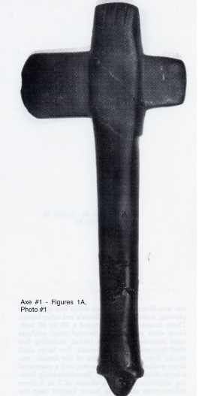

Axe #7

Several sources made reference to a monolithic axe being recovered in the early 1860's from a burial mound in York District, South Carolina. Reference to this axe first appears in Charles C. Jones's 1873, Antiquities of the Southern Indians; but no other details or history was given by any of these sources. (Saville, 1916: 3, Waring, 1968: 82-86)

Axe #8 - Figure 1G

Another specimen is reported from near Willsboro in Essex County, New York. Museum records indicate the axe was purchased in 1930, but no background information was included. This axe is curated at the Museum of the American Indian; Heye Foundation, New York, New York; catalog number MAUHF: 17/6294. (Waring, 1968: pg 82-86; personal cummunications, Museum of the American Indian; Heye Foundation)

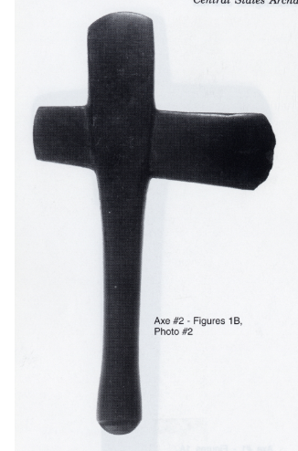

Axe #9 - Figure 1H

The latest reported monolithic axe was found by Raymond L. Weatherly in April of 1968, along a tributary creek of the Cumberland River, east of Nashville, Tennessee. This example, the smallest reported axe, measures 9 inches long, 4 1/2 inch celt length. and is made of greenstone This axe was found after a stone coffin was opened by plowing, exposing a male/female red ocher burial. Three limestone slabs covered a 36 by 60 inch, black slate stone coffin. Several other artifacts were recovered from this burial, including five shell-tempered ceramic vessels; five large shell beads, from the throat area of the female; one large worked piece of hematite; and a portion of a large chipped flint blade. Sometime later, farm­ing activities exposed a cluster of 7 to 8 stone coffins, with the above burial located near the center of the cluster. As of this date, this axe is in the private collection of J. Clements Caldwell, Danville, Kentucky. (Brehm and Smothermon, 1989: pg 26-35; personal communications, J. Clements Caldwell)

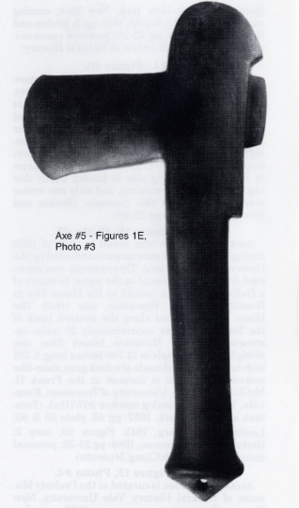

Six monolithic axes are known to exist from Spiro, located along the Arkansas River in Le Flore County, Oklahoma. All of these examples were recovered from a log tomb in Craig Mound, also known as the Great Temple Mound; site 34Lf40. These axes were recovered between 1933 and 1935 by the Pocola Mining Company, a small group of individuals who excavated the mounds prior to excavations by the University of Oklahoma. Most of these axes were encrusted with a heavy rust-colored iron deposit or patina. (Per­sonal communications, University of Oklahoma)

Axes #10 & 11 - Figures 1I & 1J

Two specimens were recovered which represent garfish effigies, carved in bas-relief. The upper end of the handle tapers to a squared 'point' where a row, or jaw of exaggerated, interlocking teeth tap­ers downward to the top of the celt. The first gar effigy axe is 14 inches long, with a 6 1/2 inch celt. A circle, representing the eye, is carved on both sides of this axe. The second gar effigy axe is 13 1/4 inches long, with a 6 1/2 inch celt. Hints of eyes exist on this axe, but are very faint and al­most undetectable. Both axes are curated at the Gilcrease Museum, Tulsa, Oklahoma; catalog numbers 6125.18911 and 6125.1781, respectively.

Axe #12 - Figure 1K

The third specimen measures 13 3/4 inches with 6 3/8 inch celt length, and is a fine example of the classic Moundville-Etowah type axe. This axe is curated at the Gilcrease Museum, Tulsa, Ok­lahoma; catalog number 6125.18910. (Waring, 1968: pg 82-86, personal communications, Gil-crease Museum)

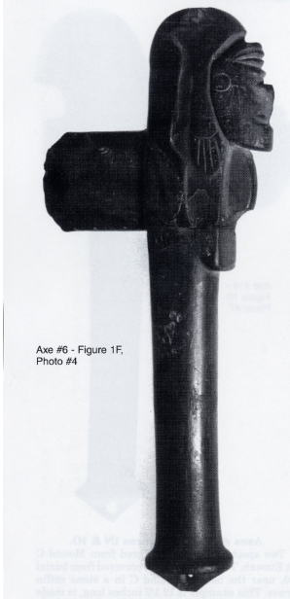

Axe #13

The fourth specimen measures 11 3/4 inches, with a 5 7/8 inch celt. This axe is of the Moundville­Etowah type and is in a very poor state of preser­vation. Only one writer makes reference to this example, and it was last reported in the private collection of Calude U. Stone. (Brehm and Smothermon, 1989: pg 48)

Axe #14 - Figure 1L, photo #5

The fifth specimen is a greenstone axe measur­ing 11 3/4 inches, and although well finished, shows some tool marks This axe is curated at the Museum of the American Indian; Heye Founda­tion, New York, New York; catalog number MAI/ HF: 20/7103. (Waring, 1968: pg 82-86; Brehm and Smothermon, 1989: pg 48)

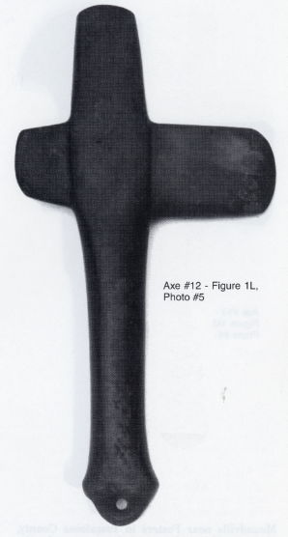

Axe #15

A fragment of a sixth axe was also reported recovered from Spiro, but no other details were given. (Missouri Arch: 46 & 180) Two monolithic axes are known to exist from the area surrounding Moundville, located along the Black Warrior River in Halefftiscaloosa Coun­ties of Alabama; site 1111500.

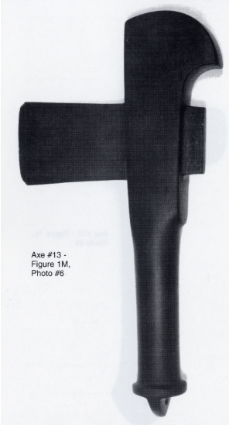

Axe #16 - Figure IM, photo #6

The first specimen was recovered from a field in the early 1900's by plowing near one of the larger mounds at Moundville in Hale County, Alabama. This example is 11.6 inches long and is made of a highly polished greenstone or amphibo­lite. The upper end of the handle curves or hooks backward toward the poll end of the celt. This axe is one of the finest examples of the Moundville­Etowah type axe and is curated at the Museum of the American Indian; Heye Foundation, New York, New York; catalog number MAI/HF: 17/891. (Saville, 1916: pg 4; Foreman and Fundaburk, 1957: plate 90)

Axe #17

Approximately one-third of another specimen was recovered from a field about 7 miles north of Moundville near Fosters in Tuscaloosa County, Alabama. The 5 - 5 1/2 inch fragment made of a metamorphosed schist represents the upper han­dle of the axe, extending to just below the celt. The poll end of the celt is complete while the bit end of the celt is broken where the celt and the handle meet. A human face is intricately carved in bas-relief on the upper end of the handle, facing the poll end of the celt. A turban is portrayed on the head with the forehead sloping downward to­ward a heavy brow ridge. The eyes are ellipitcal, with a flat nose and flaring nostrils. The lips are pronounced, with the mouth open and the tongue partially protruding. A tunic is worn beginning under the neck and extends to below the ears. This fragment probably represents one of the most elaborately carved axes and was last reported in the private collection of James Willard Dorrah, Buhl, Alabama. (Miller, 1958: 182-183)

Six monolithic axes are known to exist from the area surrounding Etowah, located along the Etowah River in Bartow County, Georgia; site 9Brl. All of these axes were recovered from Bartow County, except one example from Cherokee County.

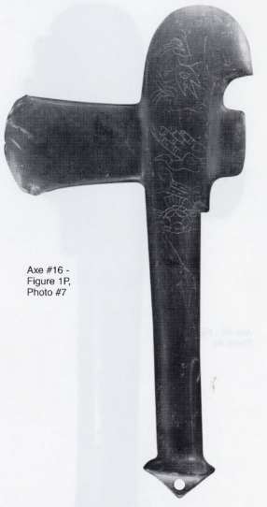

Axes #18 & 19 - Figures IN & 10

Two specimens were recovered from Mound C at Etowah. The first axe was recovered from burial 50, near the base of Mound C in a stone coffin grave. This example is 121/2 inches long, is made of a highly polished blue-grey limestone and was recovered by Warren K. Moorehead during excava­tions conducted at Etowah in the 1930's. This axe was once in the possession of Philips Academy, Andover, Massachusetts, but has since disap­peared. (Moorehead, 1932: pg 81-82, 100; personal communications, Philips Academy). The second example was recovered by Lewis H. Larson, Jr., during excavations conducted at Etowah in the mid-1950's. This example is 17 inches long and is made of a medium polished greenstone. This axe was recovered from the pelvis region of an "eagle warrior" burial and is curated at the Georgia De­partment of Natural Resources, Etowah Indian Mounds State Historic Site, Cartersville, Georgia; catalog number 442. (Foreman and Fundaburk, 1957: plate 90; Waring, 1968: pg 82-86; Brehm and Smothermon, 1989: pg 45; personal communica­tions, Etowah Mounds, Museum)